California 420 Sales

After two quarters of softening cannabis sales in California, 420 brought a much-needed boost to the Golden States cannabis market.

- With daily dollar sales in California totaling ~$21 million on 420, the holiday brought in the highest daily sales total of any day so far this year.
  - 420 daily sales totaled more than double the daily sales average for the first four months of 2022.

[Source: BDSA Retail Sales Tracking, California, January-April 2022]

- Category share of sales remained roughly in line with what has been observed so far in 2022, with Inhalables (Flower and Vape in particular) taking up the lion’s share of dollar sales.
  - Even with the aggregate pricing by category showing that Flower was the most heavily discounted product category, Flower’s share of total sales remained stable at ~33%, while the Pre-roll category saw slight growth in category share on 420, ticking up to a ~17% share of total sales.

Category | Category Share, 4/20, California | Category | Category Share, April 2022, California
Accessories | 0.3% | Accessories | 0.2%
Apparel | 0.1% | Apparel | 0.1%
Concentrates | 28.0% | Concentrates | 30.1%
Devices | 1.1% | Devices | 1.3%
Edibles | 17.2% | Edibles | 15.9%
Flower | 33.2% | Flower | 33.6%
Non Infused Food | 0.0% | Non Infused Food | 0.0%
Other Cannabis | 1.0% | Other Cannabis | 0.9%
Pre-Rolled | 16.9% | Pre-Rolled | 15.5%
Shake/Trim/Lite | 0.2% | Shake/Trim/Lite | 0.2%
Sublinguals | 1.3% | Sublinguals | 1.4%
Topicals | 0.8% | Topicals | 0.8%

[Source: BDSA Retail Sales Tracking, April 20th 2022, April 2022, California]

- While markets in the Midwest and East Coast saw gains on 4/20 in 2022 compared to 2021, California daily sales failed to surpass the total seen in 2019.
  - 420 sales totaled ~$21 million in 2022, ~10% lower than the daily dollar sales total from 2021. However, daily 420 dollar sales were ~30% higher than in 2020, when the 420 sales spike was blunted by impact of Covid-19 responses.

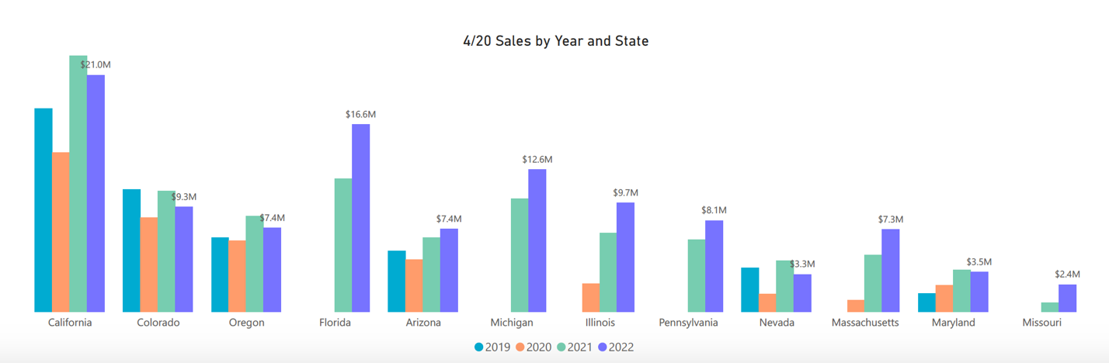

[Source: BDSA Retail Sales Tracking, 2019-2022]

